WORKING WITH EC2 COMPUTE

Step 1: Sign In to AWS Management Console.

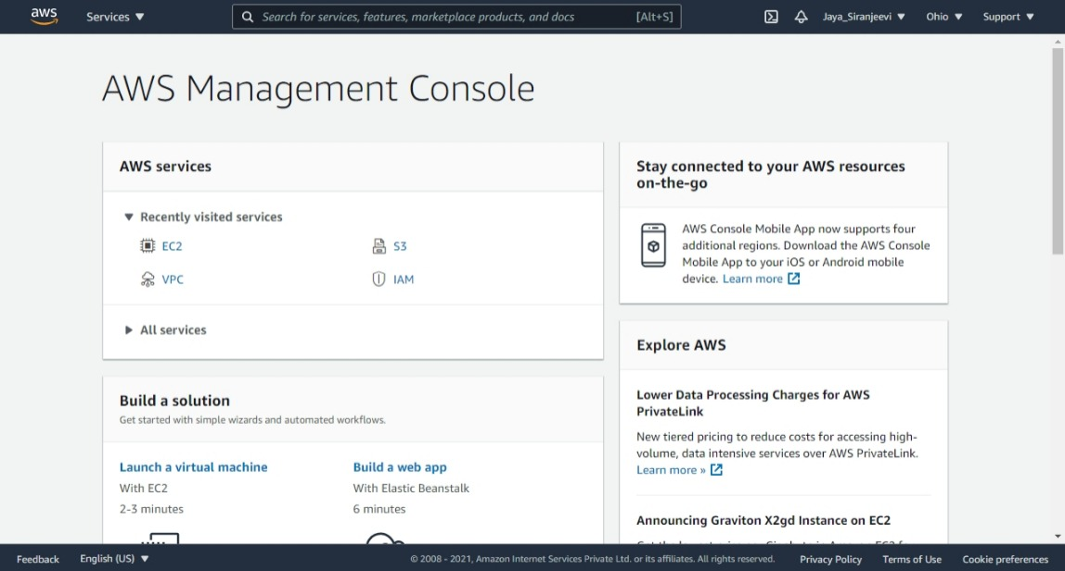

Step 2: Select EC2 Services.

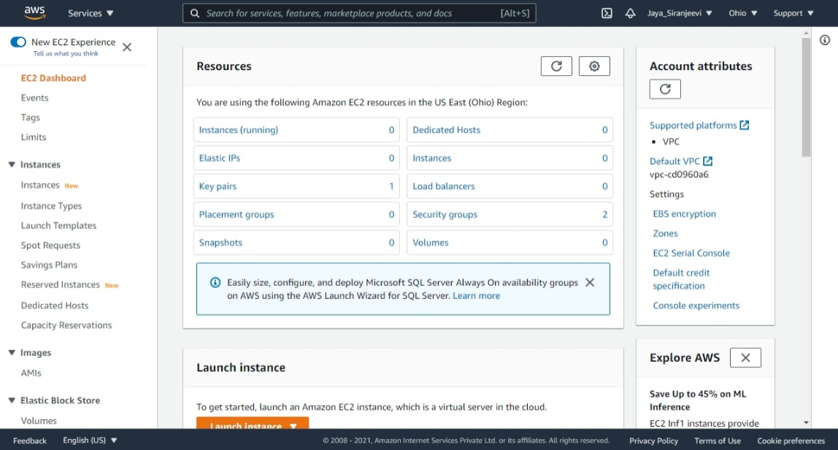

Step 3: Click on Instance & Launch new Instance.

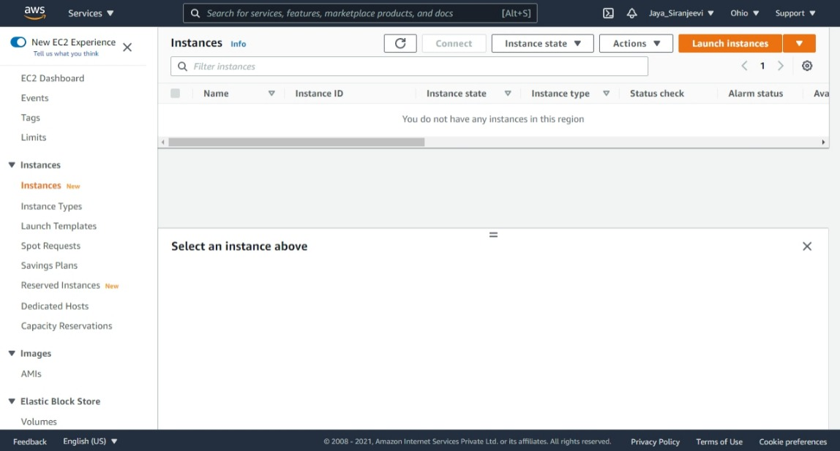

Step 4a: Choose an AMI listed below.

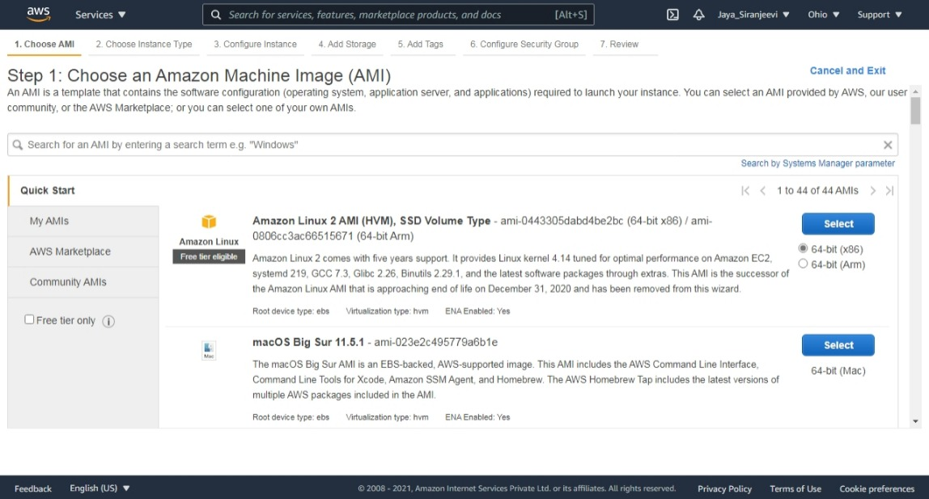

Step 4b: Choose the type of Instance according to the application.

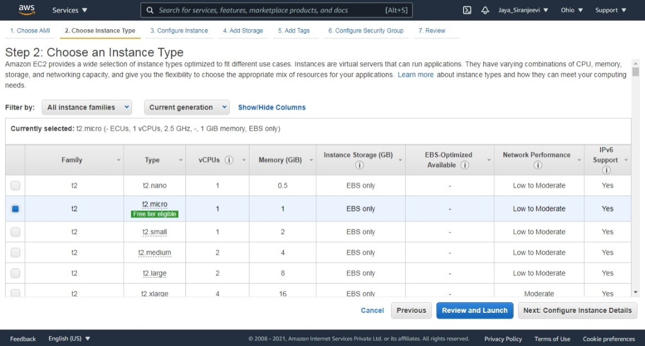

Step 4c: Configure the Instance

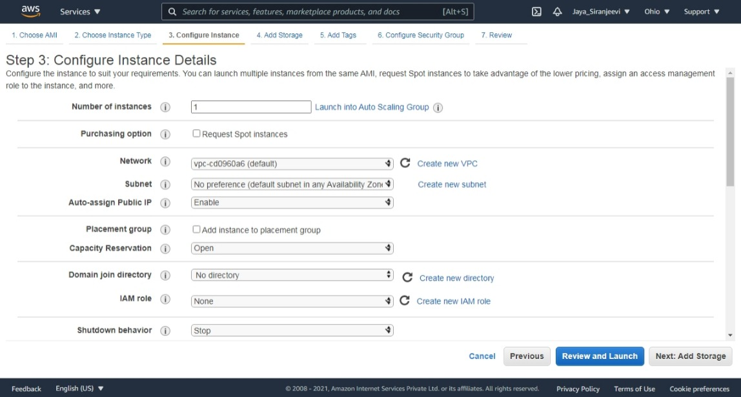

Step 4d: Adding storage to the Instance.

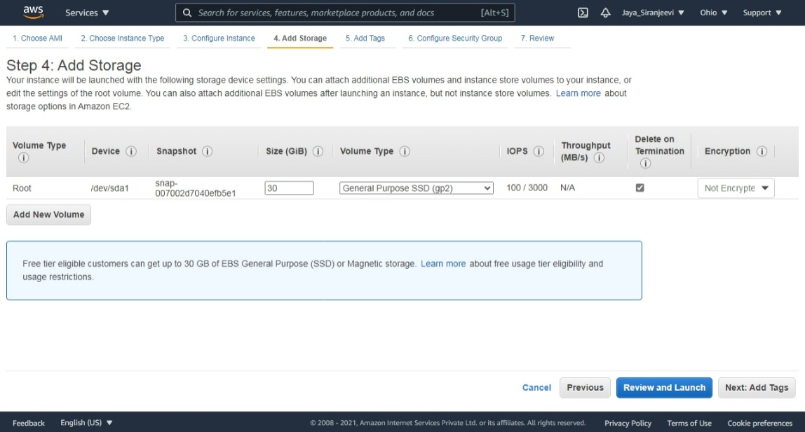

Step 4e: Adding Tag.

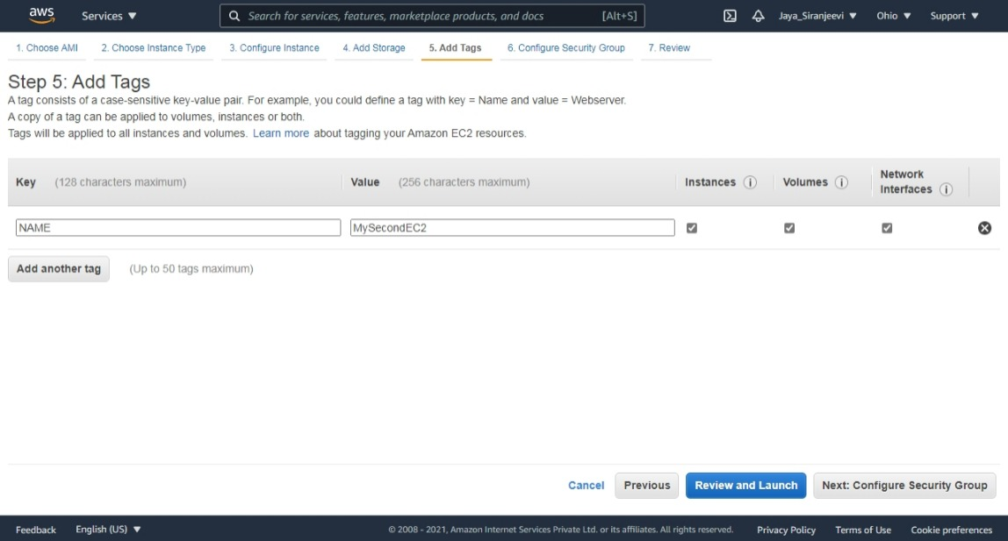

Step 4f: Configuring Security and select the Type of the Security

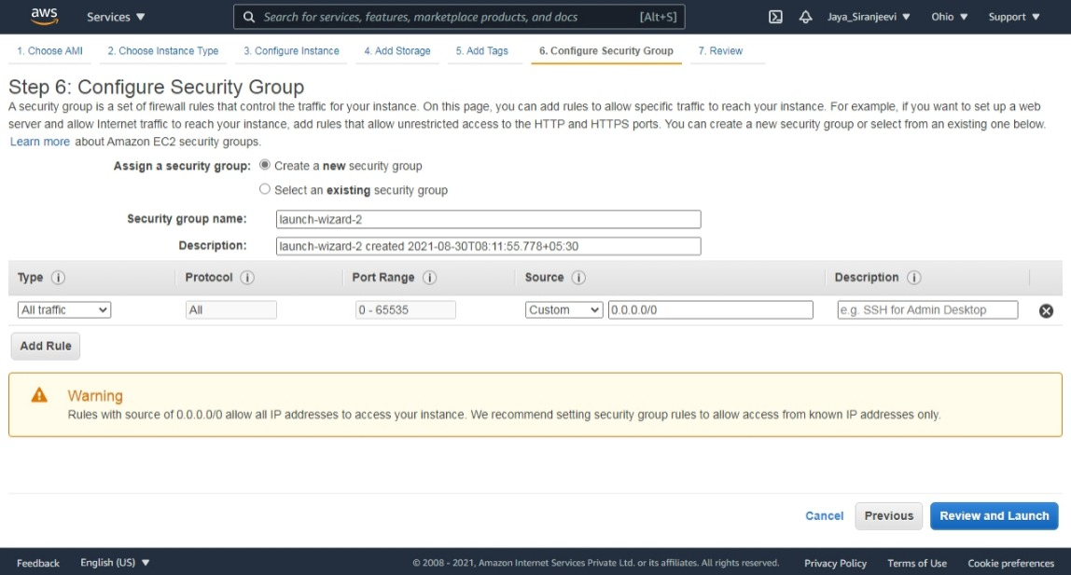

Step 4g: Review and Launch the Instance.

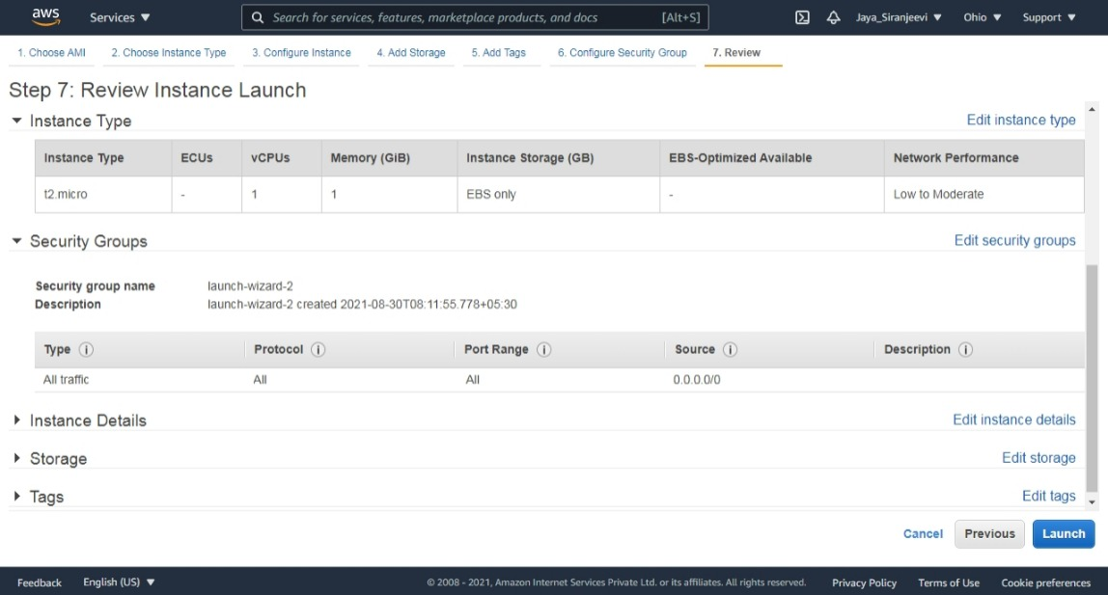

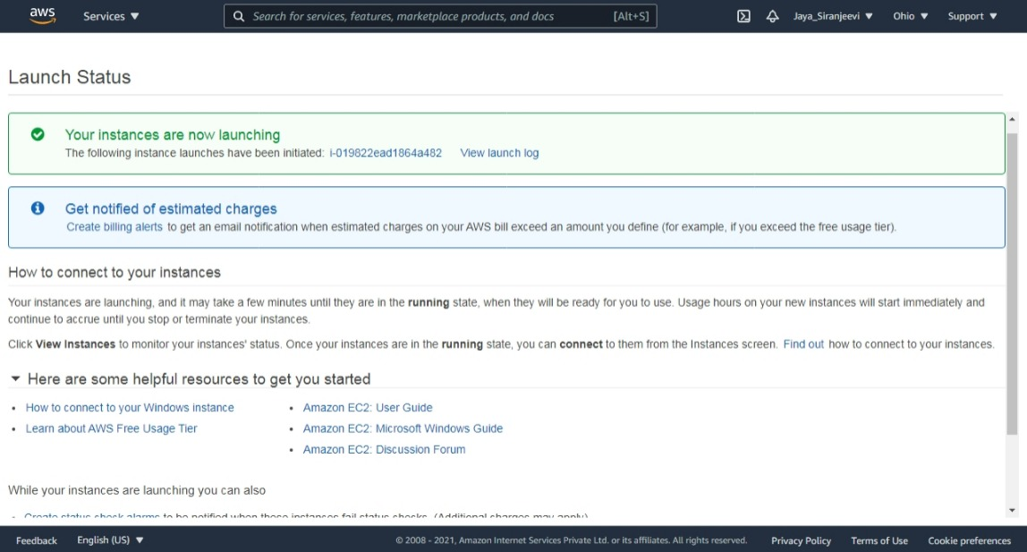

Step 5: Once the Instance is Launched, Connect the Instance.

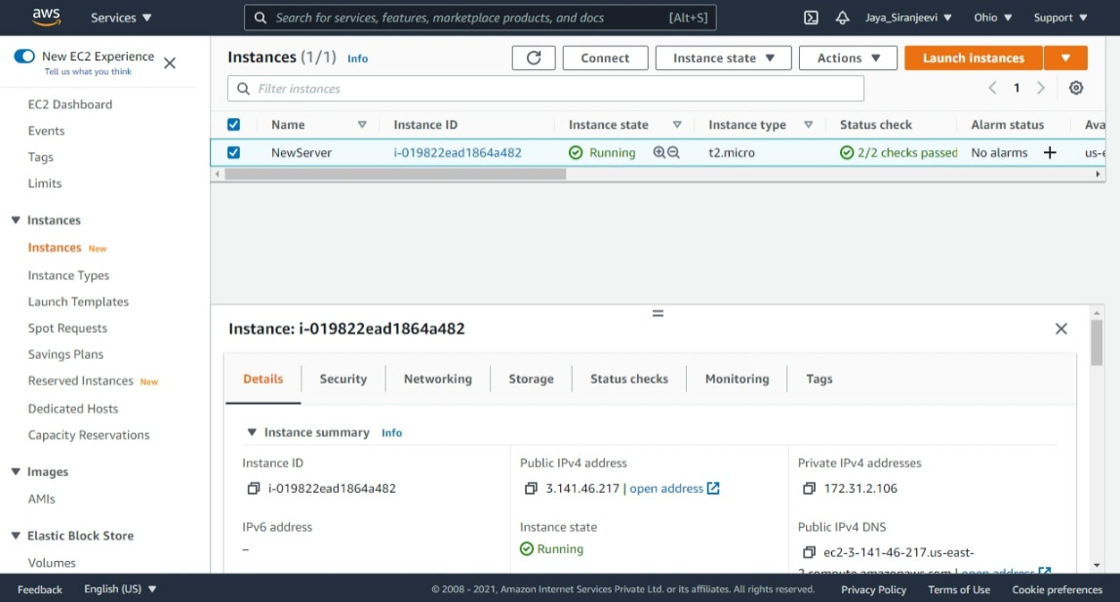

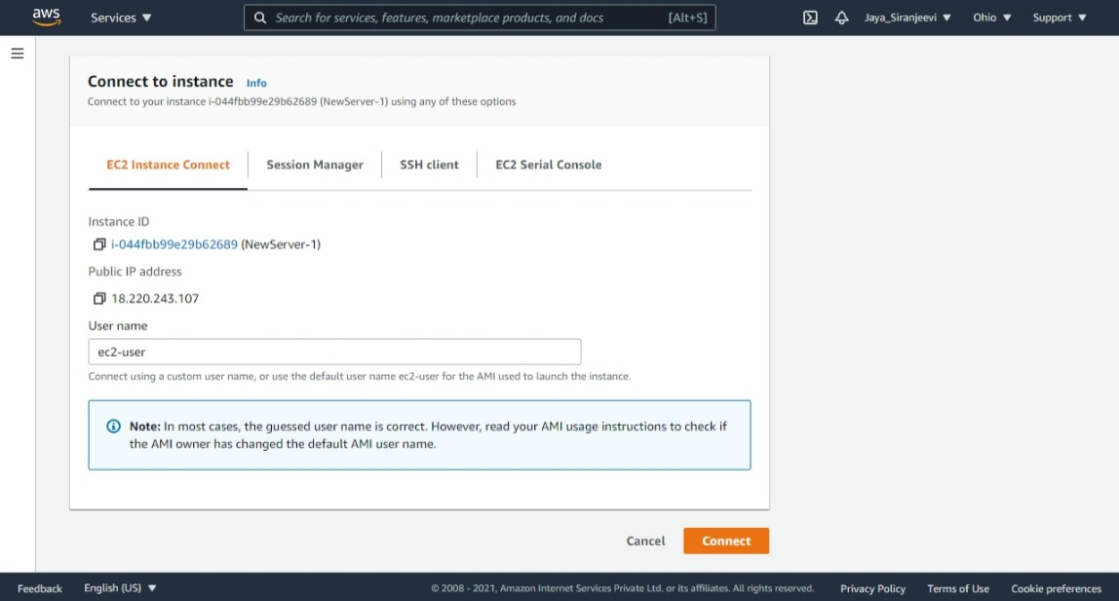

Step 6: Working on the Instance once it is connected.

Update the server using “sudo yum update” command.

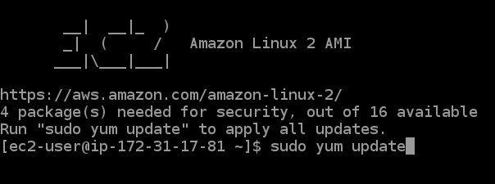

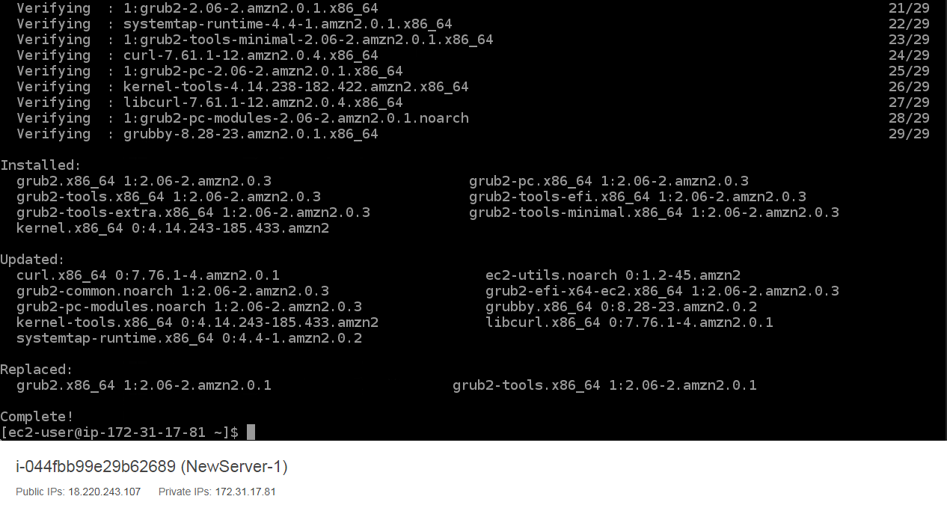

Step 7: After working on Instance, Terminate or Stop the instance.

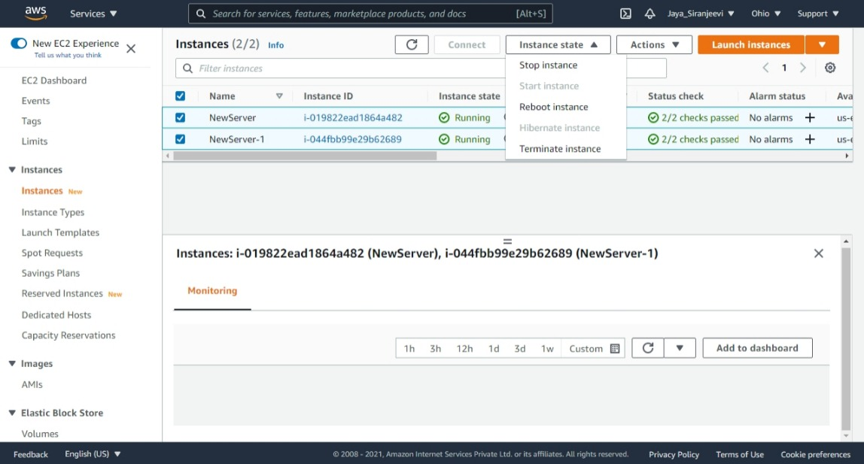

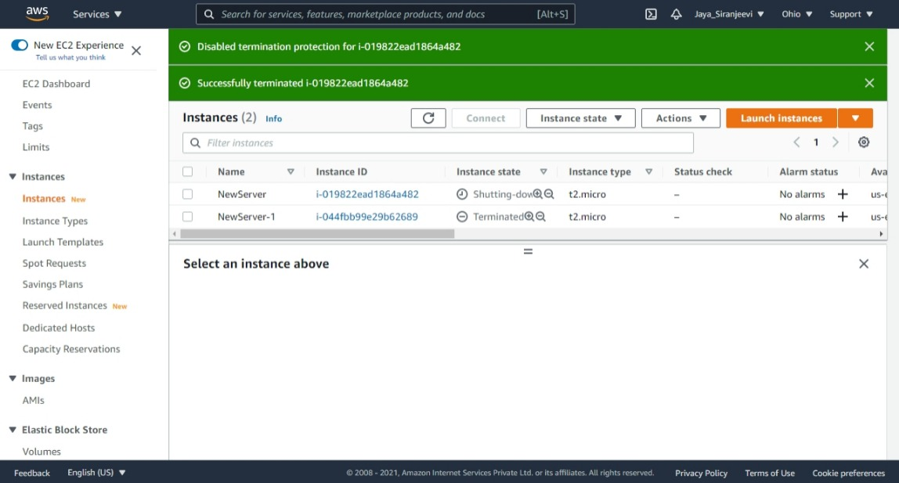

The instances has been Terminated.